**Lesson 4 Demo 14**

**Achieving Scalability**



Steps to be followed:

1. Modifying the resources, requests, and limits in a pod configuration

**Step 1: Modifying the resources, requests and limits in a pod configuration**

1. Use the following command to open the **facebookdeployment.yaml** file:

***vi facebookdeployment.yaml***



1. Edit the **facebookdeployment.yaml** file to update the replicas, resources, requests, and limits:

***---***

***apiVersion: apps/v1***

***kind: Deployment***

***metadata:***

***name: mynginx***

***namespace: test***

***spec:***

***strategy:***

***type: RollingUpdate***

***rollingUpdate:***

***maxSurge: 2***

***maxUnavailable: 1***

***revisionHistoryLimit: 4***

***paused: false***

***replicas: 6***

***minReadySeconds: 10***

***selector:***

***matchLabels:***

***role: webserver***

***jane: san***

***matchExpressions:***

***- {key: version, operator: In, values: [v1, v2, v3]}***

***template:***

***metadata:***

***name: web***

***labels:***

***role: webserver***

***version: v3***

***tier: frontend***

***jane: akil***

***spec:***

***containers:***

***- name: nginx***

***imagePullPolicy: IfNotPresent***

***image: nginx***

***ports:***

***- containerPort: 80***

***protocol: TCP***

***resources:***

***requests:***

***memory: "100Mi"***

***cpu: "300m"***

***limits:***

***memory: "128Mi"***

***cpu: "500m"***

***---***

***apiVersion: v1***

***kind: Service***

***metadata:***

***name: web-service***

***namespace: test***

***labels:***

***role: web-service***

***spec:***

***selector:***

***role: webserver***

***type: NodePort***

***ports:***

***- port: 80***

***nodePort: 32003***

***---***

***apiVersion: apps/v1***

***kind: Deployment***

***metadata:***

***name: mynginx***

***namespace: test***

***spec:***

***strategy:***

***type: RollingUpdate***

***rollingUpdate:***

***maxSurge: 4***

***maxUnavailable: 1***

***revisionHistoryLimit: 4***

***paused: false***

***replicas: 6***

***minReadySeconds: 10***

***selector:***

***matchLabels:***

***role: webserver***

***jane: akil***

***matchExpressions:***

***- {key: version, operator: In, values: [v1, v2, v3]}***

***template:***

***metadata:***

***name: web***

***labels:***

***role: webserver***

***version: v1***

***tier: front***

***jane: akil***

***spec:***

***containers:***

***- name: nginx***

***imagePullPolicy: IfNotPresent***

***image: nginx***

***ports:***

***- containerPort: 80***

***protocol: TCP***

***resources:***

***requests:***

***memory: "100Mi"***

***cpu: "300m"***

***limits:***

***memory: "128Mi"***

***cpu: "500m"***

***---***

***apiVersion: v1***

***kind: Service***

***metadata:***

***name: web-service***

***namespace: test***

***labels:***

***role: web-service***

***spec:***

***selector:***

***role: webserver***

***type: NodePort***

***ports:***

***- port: 80***

***nodePort: 32003***

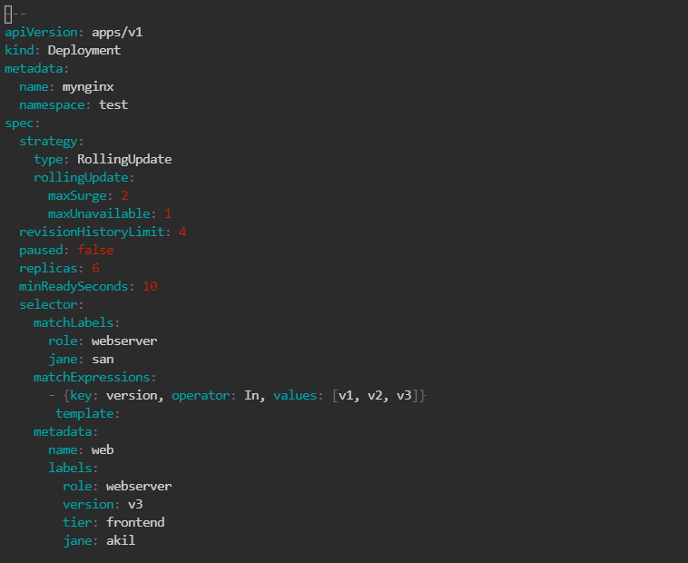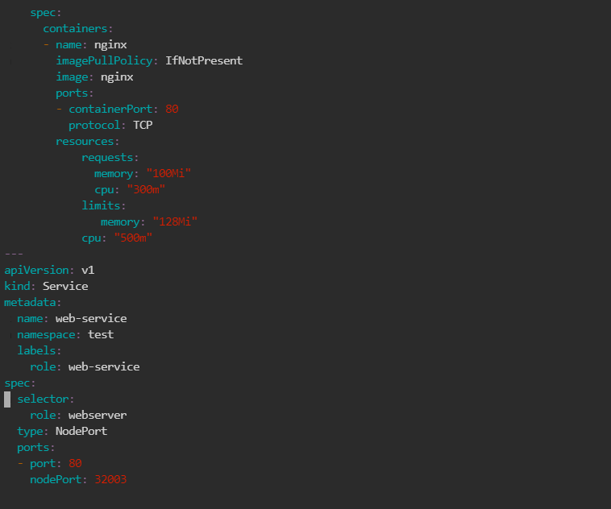

1. Use the following command to apply the changes:

***kubectl apply -f facebookdeployment.yaml***

1. List the updated deployment using the below command:

***kubectl get pods -n test***

1. Describe the pod and see the description:

***kubectl describe pod mynginx -n test***

